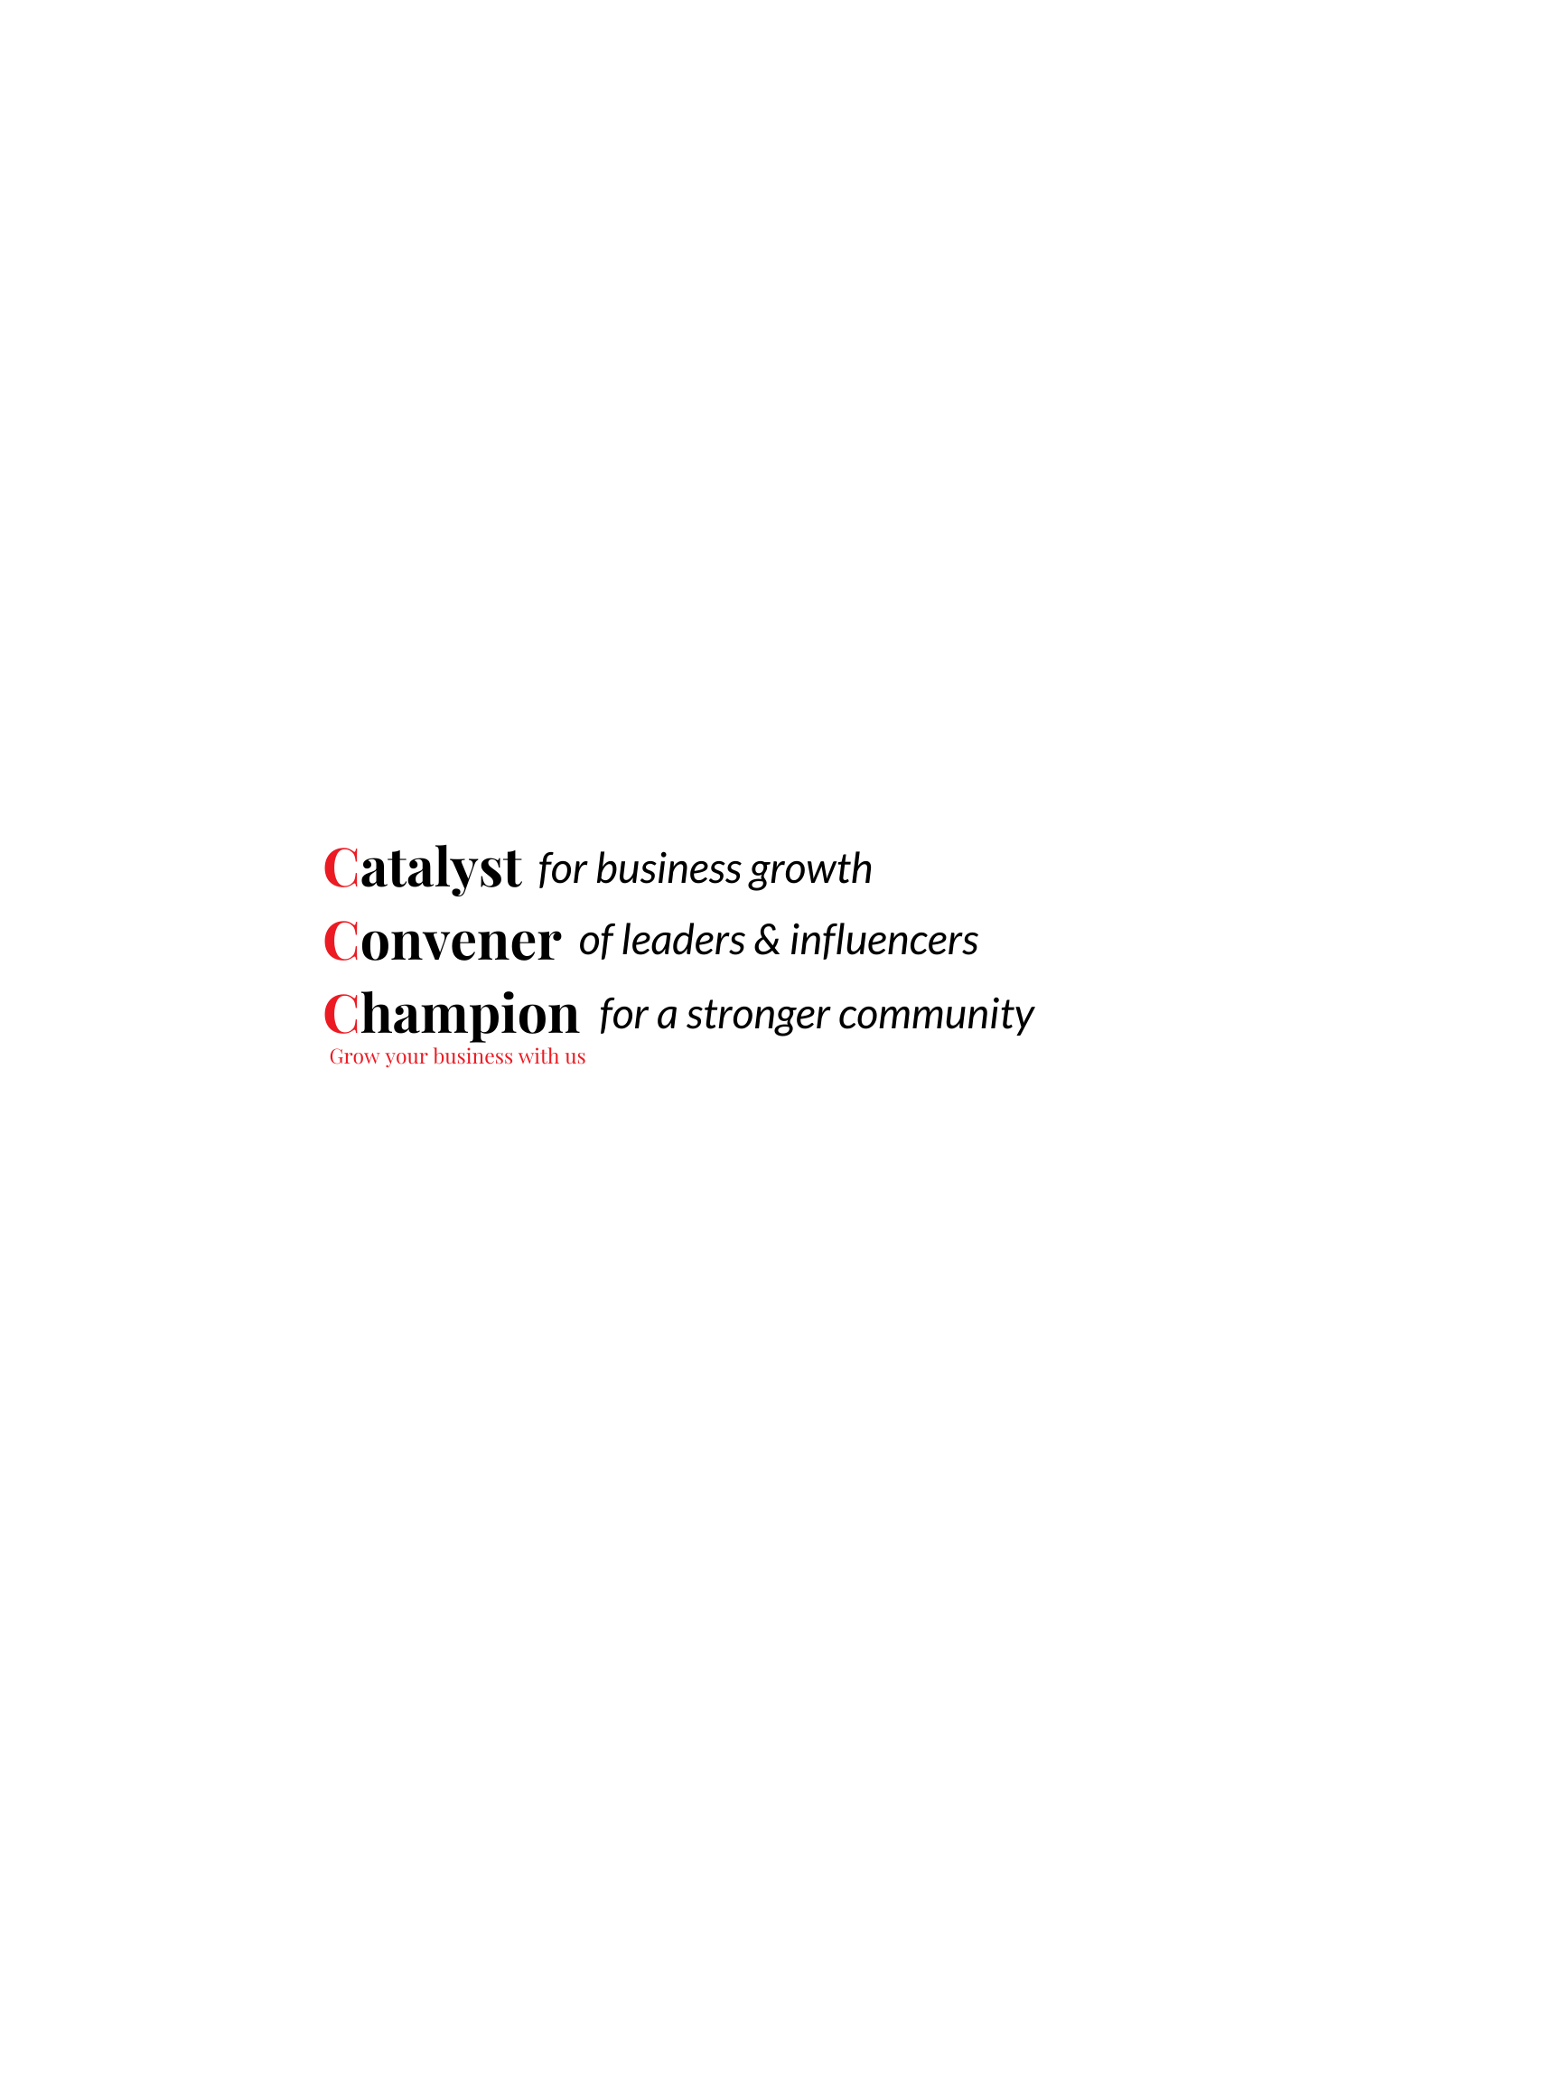

April 1, 2020

«Main_Profile_First_Name» «Main_Profile_Last_Name»

«Profile_Name»

«Address1»

«City», «StateProv» «ZipPostal_Code»

Dear «Main_Profile_First_Name»,

On behalf of The Silicon Valley Organization Staff and our Board of Directors, we would like to thank you for your support over the last year. Your financial support is essential to maintain the SVO’s operations, but we are also very sensitive to the impacts that the COVID-19 pandemic and resulting “shelter in place” order may be having on your business and the challenges this poses for you as your investment renewal date approaches. If your business is impacted by COVID-19 and you are unable to pay your membership at this time, please communicate your needs. We would be happy to work out an extension or payment plan.

Your continued commitment enables us to:  
• **Stimulate the local economy** through programs, events, and services that spotlight area business, promote business activities, and encourage entrepreneurs;  
• **Advocate for business** by building positive relationships with local, state, and federal elected officials to promote a pro-business climate and adopt positions to influence public policy;

Prior to the COVID-19 pandemic, 2020 was off to an eventful start. We had already been actively advocating on your behalf at all levels of government while providing our members with opportunities to connect, learn, build relationships and increase their visibility. And even with the “shelter in place” order in effect, our team continues to work remotely to provide our members with the information, tools, resources and connections you need to survive and thrive.

Insert any relevant COVID-19 wins/updates:  
•  
•

When we return to some sense of normalcy, the need to build your network and promote your business will be more important than ever. The SVO will be ready and looks forward to working with you and the rest of members to build and maintain a thriving community.

We cannot thank you enough for your continued support. Please let us know if we can assist in providing you with any information, resources or tools during these uncertain and very challenging times.

Please feel free to reach out to our membership team with any questions about your membership or membership benefits – they can be reached at (408) 291-5260.

-The SVO Staff

Executive Committee

2020 BOARD CHAIR

Mike Bangs

Oracle Corporation

FIRST VICE CHAIR  
Rick Beatty

Lehigh Hanson

SECOND VICE CHAIR

Emily Ruvalcaba

Bridge Bank

VICE CHAIR ECONOMIC DEVELOPMENT

Tony Mirenda  
Blach Construction

VICE CHAIR PUBLIC POLICY & ADVOCACY

Anil Babbar

California Apartment Association,

Tri-County Division

VICE CHAIR   
COMMUNITY ADVANCEMENT  
Janikke Klem

Technology Credit Union

AT-LARGE

Anthony DeMaio

KBM-Hogue

Arash Firouzjaei

Achievement Engineering

Jonathan Noble  
Microsoft Corporation

Glenn Perkins

Renaissance Executive Forums

Jeanne Serpa

Republic Services

Kevin Surace

Appvance.ai

Geri Wong

Newmark Knight Frank

SVO PAC CHAIR  
Neil Collins

SCCAOR

LEGAL COUNSEL  
Geno Ashley, Esq.

Hoge Fenton

TREASURER  
Mike Fox

Goodwill Silicon Valley

IMMEDIATE PAST CHAIR

Marc Parkinson

Petrinovich Pugh & Company

PRESIDENT & CEO

Matthew R. Mahood  
*The* Silicon Valley Organization